Installing AutoCAD Electrical
- Create an account with AutoDesk.
  - First create an account on https://www.autodesk.com/ ->Then navigate to https://www.autodesk.com/education/edu-software/
  - It will then ask you to upload some form of school documentation, either your enrollment form or a picture of your student card.
  - After you have done that you will receive an email a day later for the course to confirm your verification.
- Download the installation files (can only be done after your account has been verified).
  - Open the Autodesk website https://www.autodesk.ca/en
  - Sign into your account.
  - Click on your account icon and select Products and Services.
  - Expand the AutoCAD Item and click “View all included Items”.
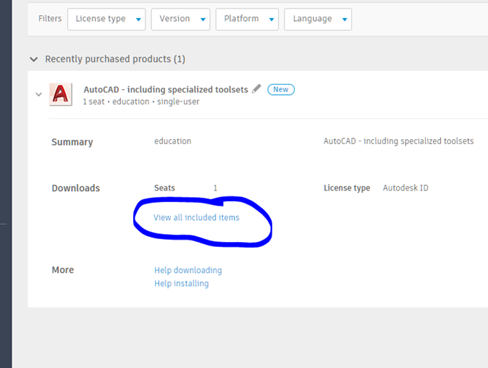
  - All AutoCAD options will appear.
  - Expand AutoCAD Electrical.
  - Click on View downloads on the latest version.
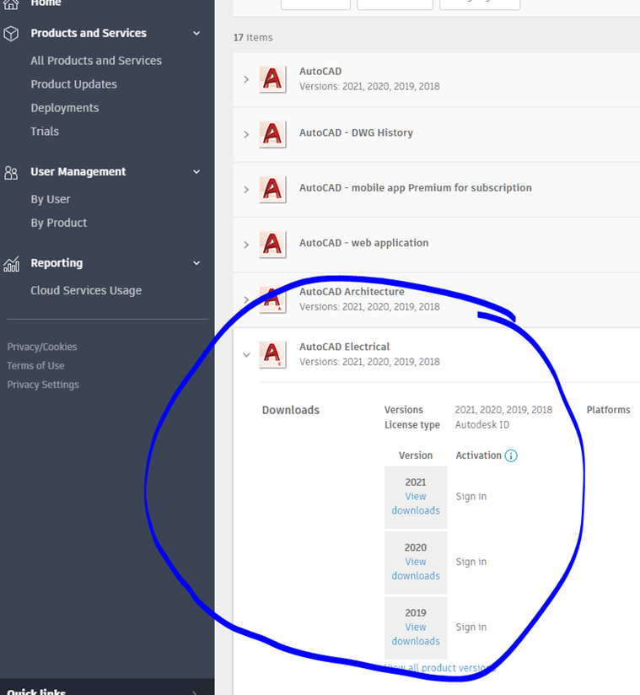
  - Download and install the files following the prompts as necessary.

